Mathematics Methods Unit 3, 2022
Name: _____________________________

Date Due: __________________________

Investigation: Volume of Swimming Pools.
Applying area under and between curves.



This investigation is an individual, take home task of 2 weeks in duration.

By ticking this box, I am verifying that the work that is submitted is my own.

Signed: ___________________________ Date: ____________________

PART A: Developing methods for calculating volume.

Below is a rectangular prism shaped swimming pool. The pool has a uniform depth of 1.2 metres.

A Cartesian plane has been placed over the surface of the pool where the origin has been positioned on the front left corner. All coordinates given are in metres.

Not drawn to scale
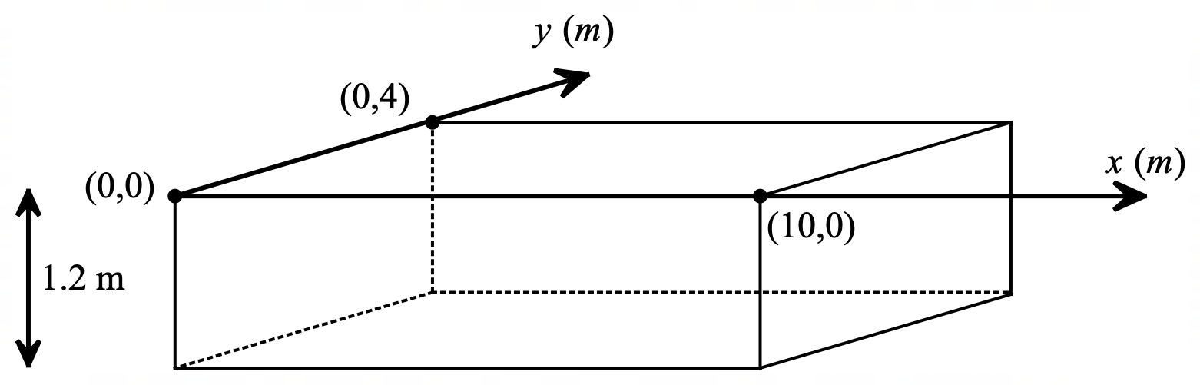

Task 1

Using volume formulas, calculate the:
a) volume of the pool in m³.
b) capacity of the pool in litres.

Task 2

Show how a definite integral could be used to calculate the volume of this swimming pool. Verify that your definite integral works by way of its calculation.

Below is a second swimming pool designed to have a variable depth, changing from 1.2 metres to 1.8 metres in depth after 4 metres from the left-hand wall of the pool.

Not drawn to scale
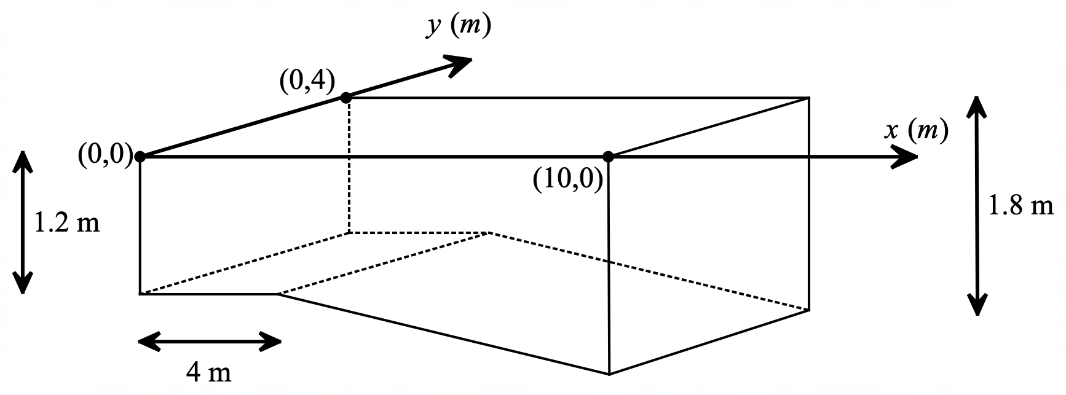

Task 3

Using volume formulas, calculate the:
a) volume of the pool in m³.
b) capacity of the pool in litres.

The diagram below shows the second swimming pool again, however, a vertical “$d$-axis” has been added to help map the depth of the pool in terms of $x$.

Not drawn to scale
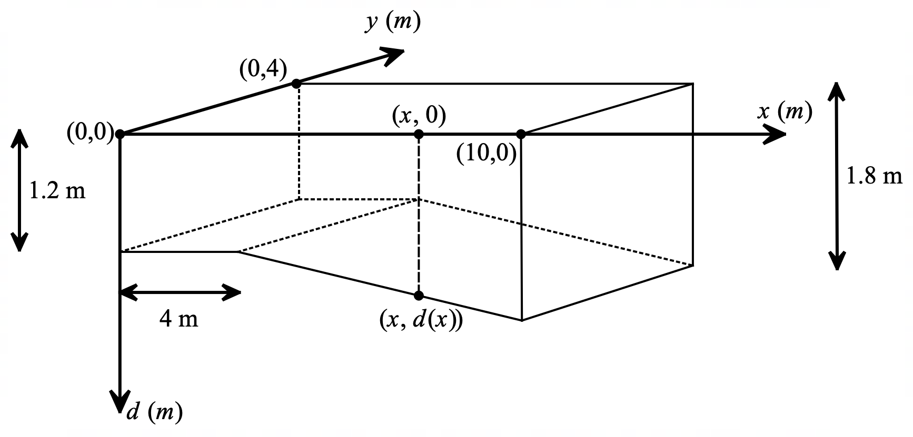

Task 4

Determine a piecewise function, $d(x)$, for the depth of the pool in terms of $x$. Take $d(x)$ as always positive, that is, $d\left(x\right)>0$ for all $x$ (see Appendix 1 for hints on how to formulate a piecewise function).

Not drawn to scale
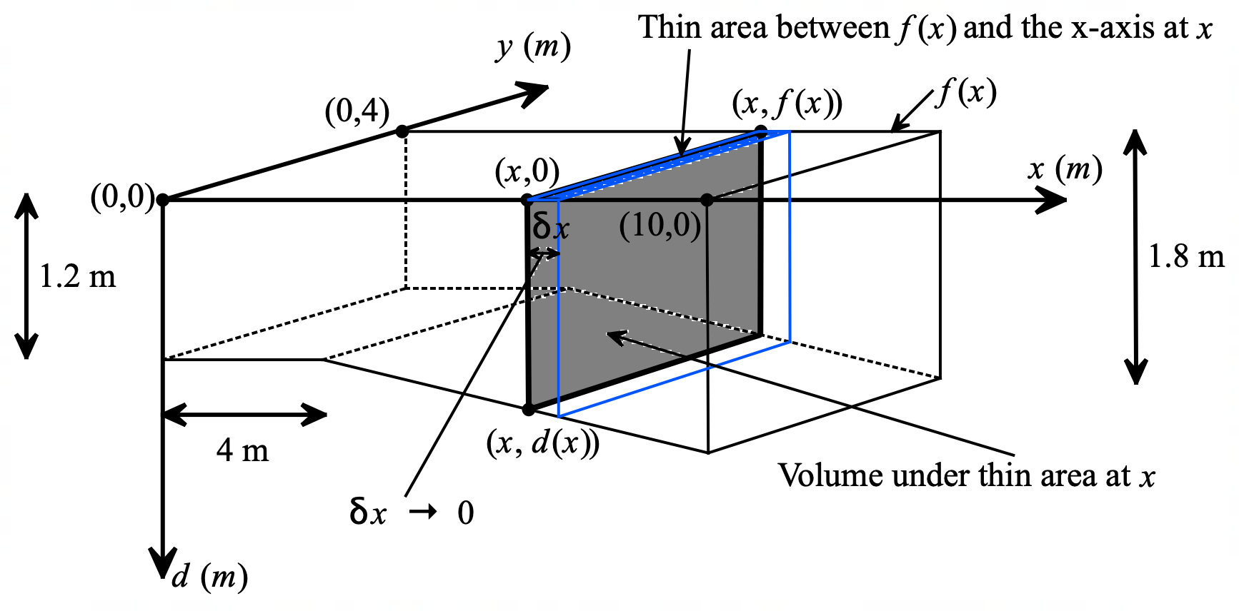

The area trapped between a curve, $f(x)$, and the $x$-axis, where $f\left(x\right)>0$, can be determined by summing the areas of infinitesimally thin rectangular strips taken between the bounds of the area in question.

In the diagram above, the area trapped between a curve, $f(x)$, and the $x$-axis defines the surface area of the water in the pool.

The diagram above shows one thin slice of volume taken from the pool as the cross-section of the pool for a particular value of $x$. (Infinitesimally thin slice as $δx→0$).

Task 5

Show how definite integral(s) could be used to calculate the volume of this swimming pool. Verify that your definite integral(s) works by way of its calculation and compare your result to your answer to Task 3.

PART B: Mathematically design your own swimming pool.

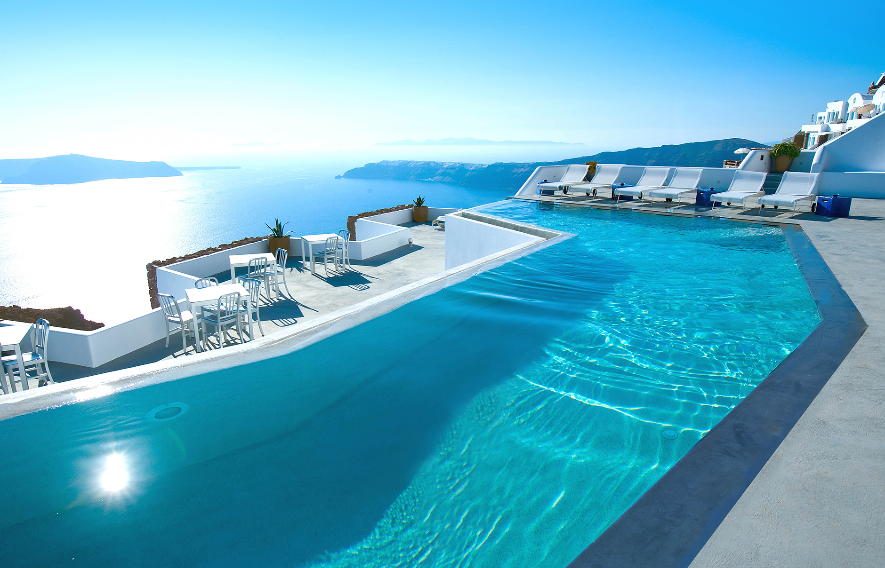
A new hotel contracts you to design a large swimming pool for their customers to enjoy.

The following tasks are to be completed on the pages that follow and/or your own supply of paper.

Task 6

You are to design a swimming pool using the following guidelines.
- The pool is to be approximately 60 metres in length (parallel to $x$-axis).
- The pool is to be approximately 30 metres wide (parallel to $y$-axis).
- The pool is to be at most 3 metres deep.
- Use mathematically defined functions to map its perimeter (see Appendix 2 for hints on how to formulate polynomial functions)
- Use mathematically defined functions to map its depth.
- The pool should be functional with a consideration to its aesthetics.

You are required to sketch your pool design using either the supplied template (back page) or using your own paper supply. You can use digital technologies to help plot your pool design. Some free graphing software include: GeoGebra and Desmos.

Clearly list all functions used and over what specific domains.

Task 7

Calculate the volume and capacity of water in your pool using definite integration methods. You must show the working out of your definite integrals and not rely in CAS calculators for the calculations.

Task 8

List any limitations to the possible design you encountered in designing your pool with regard to formulating a method using definite integrals for calculating its volume (or capacity).

Appendix 1

A piecewise function is a function built from pieces of different functions and each piece is defined over nonoverlapping domains.

Example.

The following function is continuous over the domain $\{x:-2<x≤9\}$ and is defined by two functions, one being linear and the other quadratic.

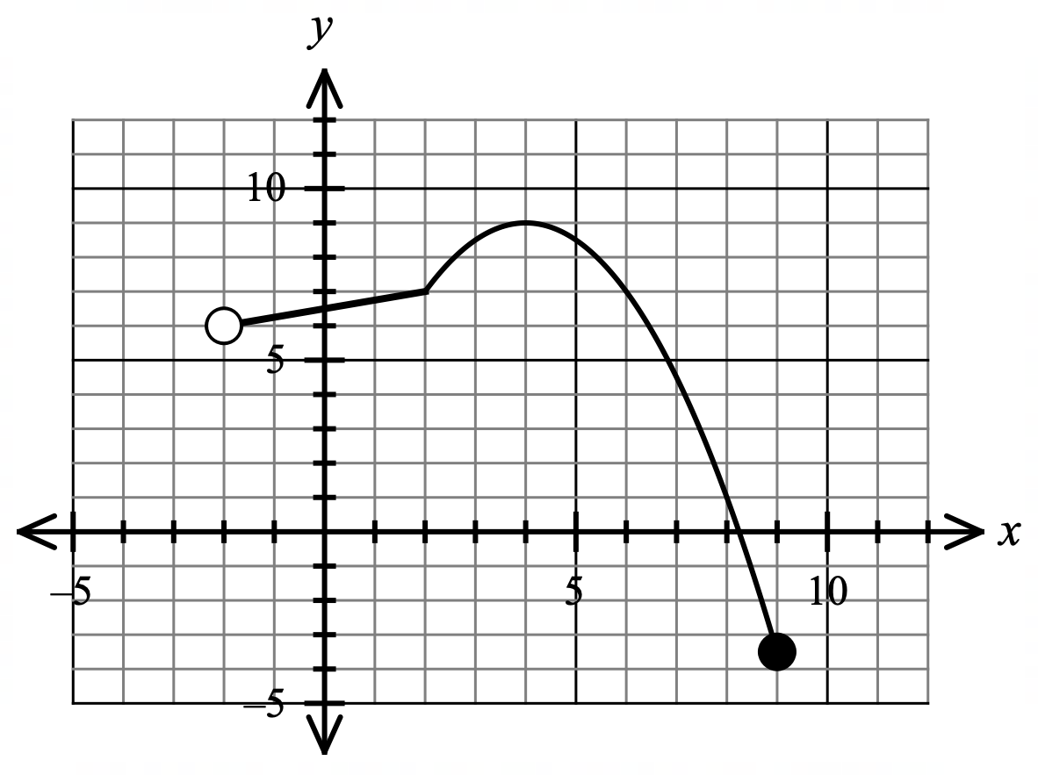

This piecewise function can be defined in the following way.

$f\left(x\right)=\left\{\begin{aligned}\frac{1}{4}x+\frac{13}{2} \\ -\frac{1}{2}x^{2}+4x+1\end{aligned}\right. \begin{matrix}-2<x≤2 \\ \\ 2<x≤9\end{matrix}$

List of different functions. Domains each different function is defined over.

Appendix 2

Formulating Polynomial Functions from Given Points.

Consider you wish to define a polynomial function that approximates the curve sketched below.

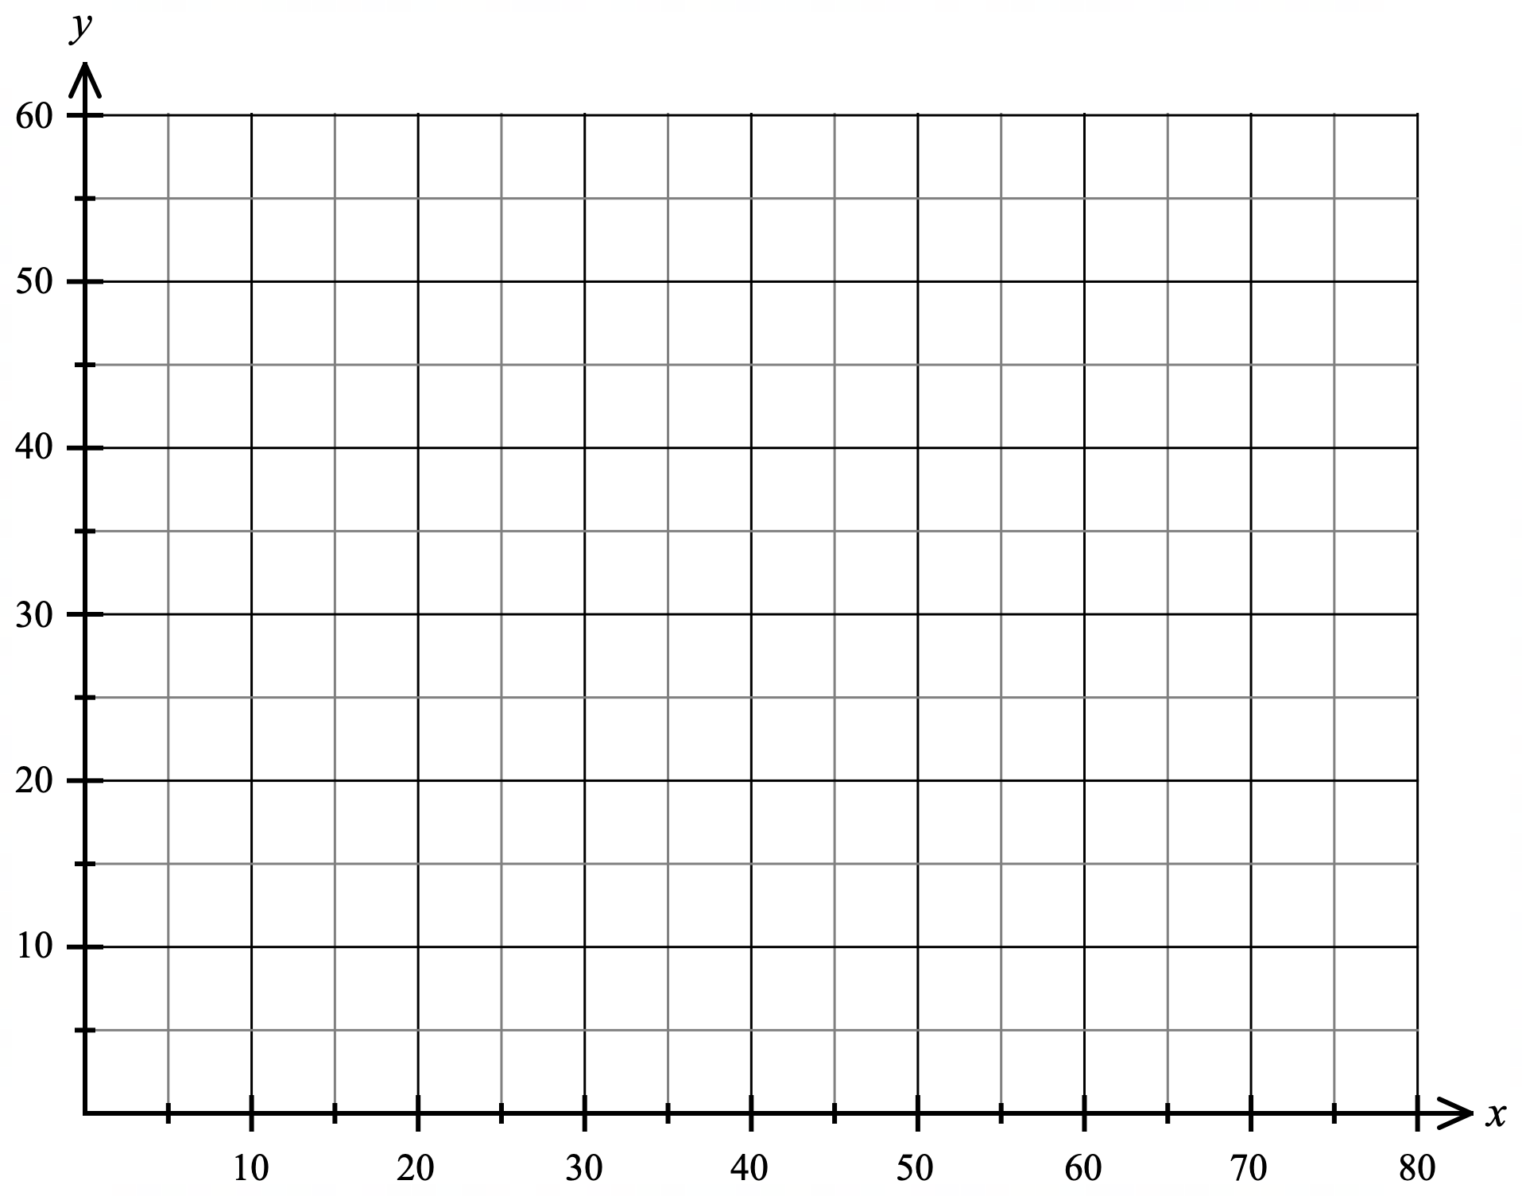

Looking at the above curve, having three turning points suggests a polynomial of degree 4 may approximate it.

That is: $y=ax^{4}+bx^{3}+cx^{2}+dx+e$

To determine the values for the coefficients $a, b, c, d$ and constant $e$, five known points on the curve are required. From the five points, a system of five equations will be formed.

However, using the point $(0, 40)$ $e=40$

The other four equations would be:

Using $(15, 50)$ $50={15}^{4}a+{15}^{3}b+{15}^{2}c+15d+40$
Using $(39, 30)$ $30={39}^{4}a+{39}^{3}b+{39}^{2}c+39d+40$
Using $(60, 47)$ $47={60}^{4}a+{60}^{3}b+{60}^{2}c+60d+40$
Using $(70, 35)$ $35={70}^{4}a+{70}^{3}b+{70}^{2}c+70d+40$

CAS can help with the solving of the system of equations.

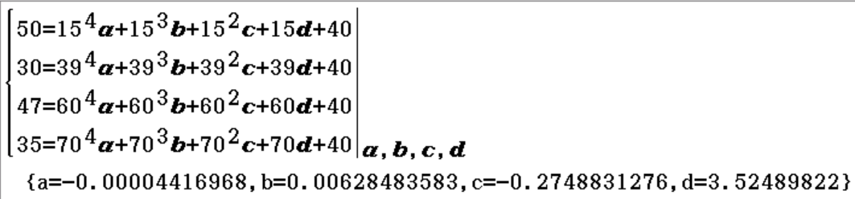

Taking the solved coefficients to 4 significant figures and plotting:

$y=-0.00004417x^{4}+0.006285x^{3}-0.2749x^{2}+3.525x+40$

we obtain an approximation of the desired curve below.

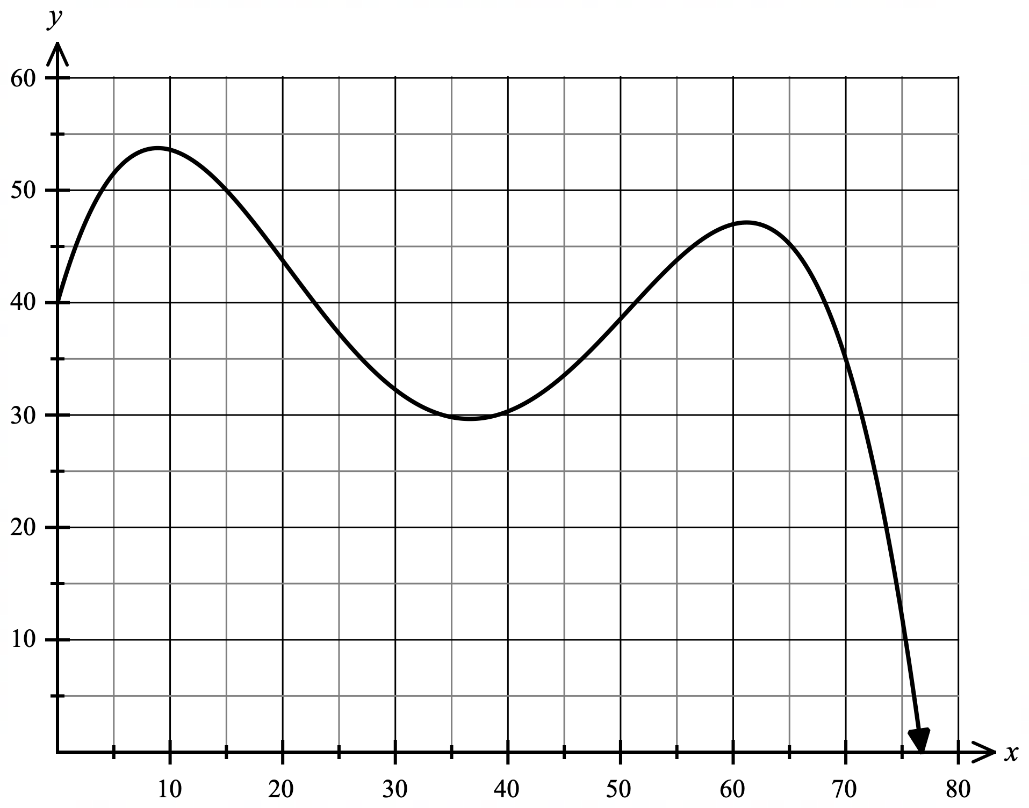

Design template.
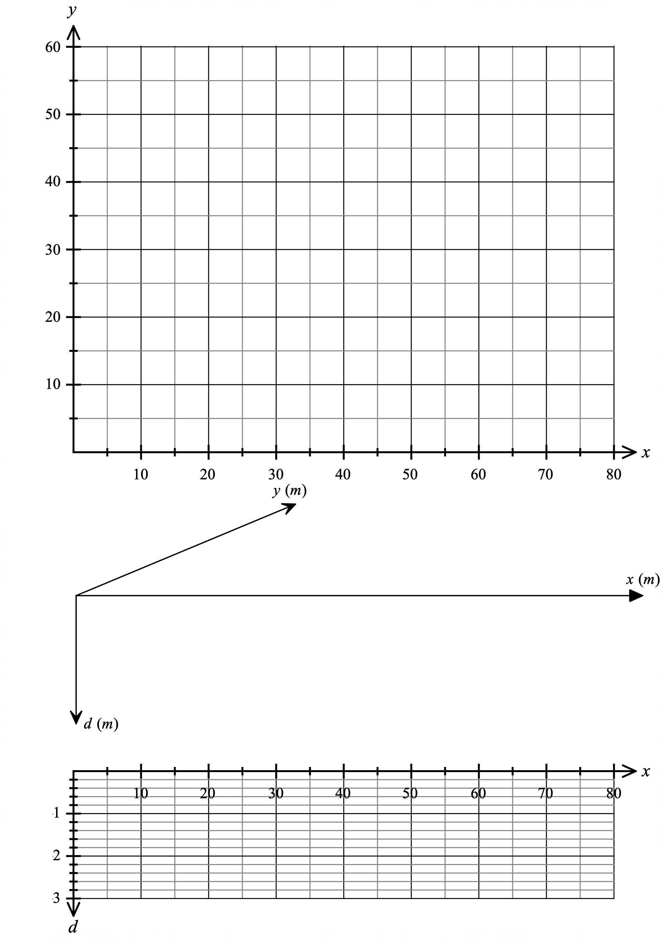

The follow pages are not for sharing with students prior to student submission of the investigation.

SOLUTIONS Answers to Part A

Task 1

a) $V=10×4×1.2$

$=48$ m³

b) $Capacity=48 000$ L

Task 2

$V=1.2×\int_{0}^{10}{4}dx$

$=1.2×{\left[4x\right]}_{0}^{10}$

$=1.2×(40-0)$

$=48$ m³

Task 3

a) $V=4×4×1.2+\frac{1.2+1.8}{2}×6×4$

$=55.2$ m³

b) $Capacity=55 200$ L

Task 4

$d\left(x\right)=\left\{\begin{matrix}1.2 \\ \\ 0.1x+0.8\end{matrix}\right.$ $\begin{matrix}for 0≤x≤4 \\ \\ for 4<x≤10\end{matrix}$

Task 5

$V=1.2×\int_{0}^{4}{4}dx+\int_{4}^{10}{4(0.1x+0.8)}dx$

$=1.2×{\left[4x\right]}_{0}^{4}+4×{\left[0.05x^{2}+0.8x\right]}_{4}^{10}$

$=1.2×\left(16-0\right)+4×\left(\left(5+8\right)-\left(0.8+3.2\right)\right)$

$=19.2+36$

$=55.2$ m³

Mathematics Methods Unit 3
Name: ______________________________

Investigation Marking Rubric: Volume of Swimming Pools
Mark ______/ 50

Grade | Interpret the task and choose the mathematics | Apply mathematical knowledge to obtain a solution | Interpret and communicates results and conclusions
A | - All tasks in Part A have correct notation including defining the piecewise function and all definite integrals  - Chooses a perimeter for the pool design in Part B based on a mixture of functions and areas between curves would be required  - Chooses a varying depth based on a mixture of functions  - Pool design indicates thought to minimise sharp edges by considering gradients between functions at their junctions  (13 – 15 marks) | - Has all calculation in Part A correct including all units and function domains  - Has plotted their pool design accurately for both the perimeter and depth while also representing the design as a 3D drawing with some accuracy.  - All definite integrals are correctly calculated  - Volume and capacity correctly calculated with units  (17 – 20 marks) | - All functions chosen to define the perimeter of their pool are clearly defined with domains  - All functions chosen to define the depth of their pool are clearly defined with domains  - Lists at least two quality limitations to the designing based on the limitations of the method of calculating the volume using definite integrals, for example:  - Circles are not able to be used  - Difficulty of avoiding ‘sharp’ corners at function junctions  - Cross-section of the pool at any point perpendicular to the x-axis and parallel to the y-axis must be rectangular  (13 – 15 marks)
B | - Is able to define the piecewise function for the depth of the pool in Part A  - Has written all definite integrals correct in Part A  - Chooses a perimeter for the pool design in Part B based on at least two curves  - Chooses a varying depth for pool based on linear and at least one curve  - Pool design indicates thought to minimise sharp edges at function junctions  (10 – 12 marks) | - Has calculated the definite integrals correct for both pools in Part A  - Has plotted their pool design accurately for both the perimeter and depth  - Most definite integrals are correctly calculated  - Volume and capacity correctly calculated  (13 – 16 marks) | - All functions chosen to define the perimeter of their pool are defined with most domains correct  - All functions chosen to define the depth of their pool are defined with most domains correct  - Lists at least one quality limitation to the designing based on the limitations of the method of calculating the volume using definite integrals, (see above in A grade for examples)  (10 – 12 marks)
C | - Identifies and writes the correct bounds for all definite integrals in Part A  - Chooses a perimeter for the pool design in Part B based on linear functions forming multi-angled sides  - Chooses a varying depth for pool based on linear functions  (9 – 11 marks) | - Has calculated the definite integral correct for the uniform depth pool in Part A  - Has plotted their pool design accurately for both the perimeter and depth  - Most definite integrals are correctly calculated  - Volume correctly calculated  (9 – 12 marks) | - All functions chosen to define the perimeter of their pool are defined  - All functions chosen to define the depth of their pool are defined  - Lists at least one limitation to the designing of their pool based on the limitations of the method of calculating the volume using definite integrals  (9 – 11 marks)
D | - Is able to identify the dimensions of the two pools in Part A required for volume calculation  - Uses correct volume formulas for prisms in Part A  - Chooses a perimeter for the pool design in Part B based on one or two linear functions and the x-axis  - Chooses a uniform depth for pool  (max 8 marks) | - Is able to determine the volume of the two pools in part A using volume of prism formulas  - Has plotted their pool design accurately for the perimeter  - Some definite integrals are correctly calculated  - Volume correctly calculated  (max 8 marks) | - Some functions chosen to define the perimeter of their pool are defined  - Lists at least one limitation to the designing of their pool, however, is not clearly linked to the method of calculating the volume using definite integrals  (max 8 marks)

